* Experiment 2
* Roll no 2010044
* I2 batch
* BUS TOPOLOGY

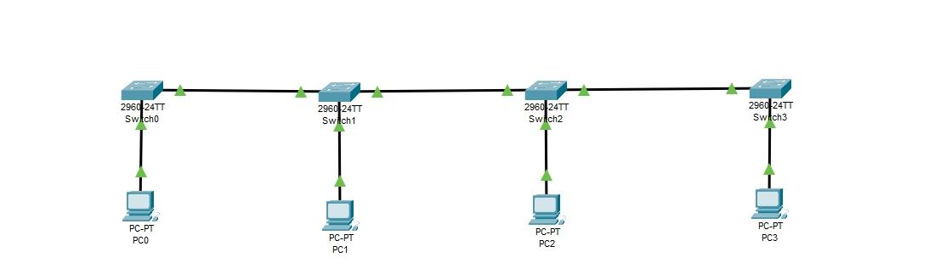

* Above Bus topology contains 4 switches and each switch is connected to one Device respectively.
* Here pc0 is the source and pc2 is destination .
* Message passes form pc0 to pc2 from switch 0, 1,2 and reaches to destination pc2.As switch is intelligent it sends the message only to device pc2.
* Pc2 sends acknowledgement to the pc0.
* STAR TOPOLOGY :-

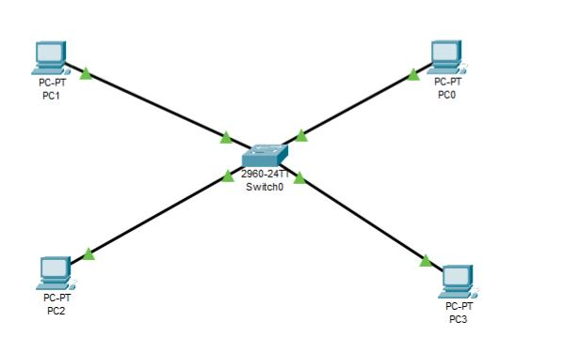

* In star topology all the devices are connected to the single switch by point to point connection.
* Here pc 3is the source and pc 1 is the destination .ction Message directly sent to the pc 1 by the switch.
* It is the most common topology in the LAN networks.
* 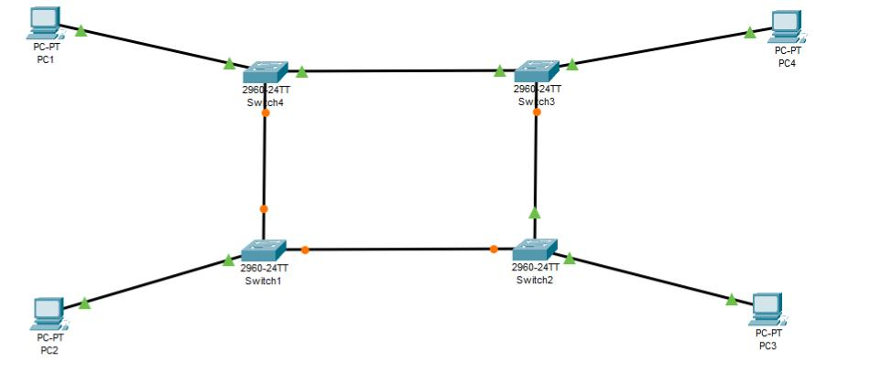RING TOPOLOGY :-
* Ring topology contains four switches connected to each other and each switch is connected to one device in a ring link manner so called as Ring topology.
* Here pc0 is source device and pc1 is destination. Because of switch the message only passes to pc1 but before this process pc0 wants to catch the token so that it can be able to send message to avoid data collision.
* After receiving the message pc1 sends acknowledgement to source.

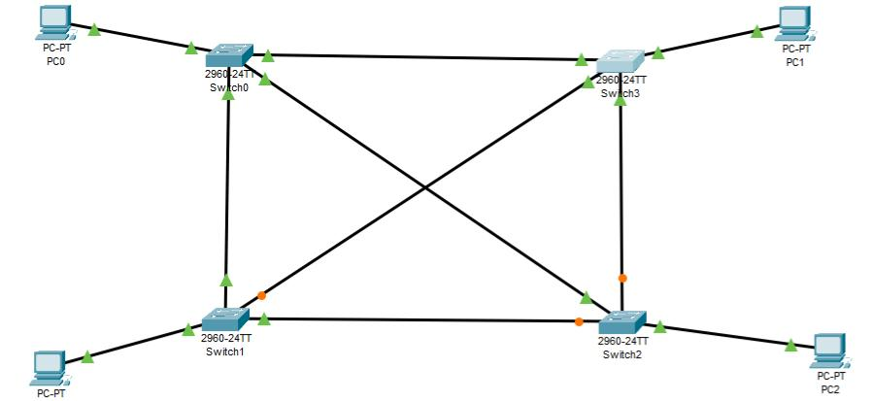

MESH TOPOLOGY :-

* Above mesh topology contains 4 switches connected to each pc seperately. All switches are connected to each other at once in mesh like manner by point to point connection so called mesh analysis.
* Here source is pc5 and destination is pc6 due to switch the message is directly passed to the pc6 through nearest path.
* Pc6 sends acknowledgement to source after message acceptance .

TREE TOPOLOGY :-

* 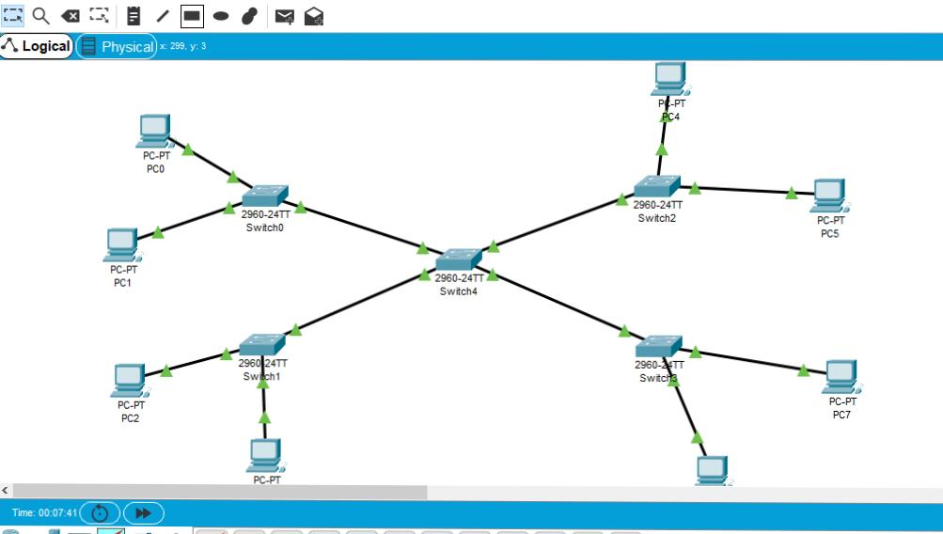Tree topology contains 5 switches connected in the step wise form like branches then each switch is connected to the two PC’s. The arrangement is called as Tree topology.
* Here source is pc0 and destination is pc2 .
* The message traverses the least possible path to reach the destination to pc2.pc2 sends acknowledgement after receiving the message in the reverse path.